

**Booking Hotel web PROJECT REPORT**

**Software Requirement Specification**

# Group 1

Đỗ Hoàng Sơn

Đoàn Quang Nhật Minh

Trần Quang Huy

Nguyễn Trọng Hiếu

Công Hậu

– Da Nang, June 14th 2022 –

**Table of Contents**

I. Introduction 3

1. Describle the situation 3

2. Purpose 3

2. The topic's scope 3

II. Software Requirement Specification 4

1. Overall Description 4

1.1 Product Overview 4

1.2 Business Rules 5

2. User Requirements 6

2.1 Overview 6

2.2 <<Booking Hotel>> 6

3. Functional Requirements 8

3.1 System Functional Overview 8

3.2 <<Feature Name 1>> 10

3.3 <<Feature Name 2>> 10

4. Non-Functional Requirements 11

4.1 External Interfaces 11

4.2 Quality Attributes 12

5. Other Requirements 14

# I. Introduction

* 1. ***Describe the situation***

While people's living levels are rising, tourism demand is expanding, and the necessity for hotels with decent rooms and services to rest and unwind is becoming increasingly popular. Help guests pick the room of their choice by using the internet to look for room information at the hotel.

The website enables hotel personnel to do duties such as updating client information, seeing information about hotel services, room numbers, and employees, and paying bills without having to spend a lot of time handling enormous volumes of data.The use of information technology in hotel management in accordance with user needs has become increasingly required and vital as a result of human efforts.

* 1. ***Purpose***

Customers may use this website to get reliable information on hotel rooms around the country and how to book them online. The data is updated often and accurately. As a result, the distance between the consumer and the hotel offering the service is reduced, and information about the hotel's rooms is delivered to the customer fast.

**1.3 *The topic's scope***

Provide a website with information on the hotel's current rooms, as well as a tool to assist the hotel in managing its operations more easily, efficiently, and cost-effectively.

# II. Software Requirement Specification

## 1. Overall Description

## 1.1 Product Overview

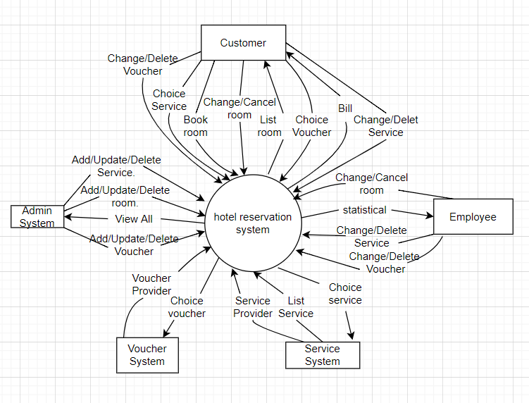

## 1.2 Business Rules

|  |  |
| --- | --- |
| ID | Rule Definition |
| BR-01 | Check-in time must be within the day of check-in, not more than days. |
| BR-02 | Room delivery as soon as customers come to the reception room. |
| BR-03 | Provide all services and vouchers to customers. |
| BR-04 | Support customers when customers have requests about services at the hotel. |
| BR-11 | Designate an official hotel staff who can report the number of reservations and hotel services. |
| BR-12 | Hotel staff appoint a new bill manager who can create, modify or delete hotel services. |
| BR-24 | When a customer makes a reservation at the hotel, the front desk must provide a full range of services to the customer. |
| BR-33 | Network transmissions that involve financial information or personally identifiable information require 256-bit encryption. |

## 2. User Requirements

### 2.1 Overview

#### a. Use Case Diagram

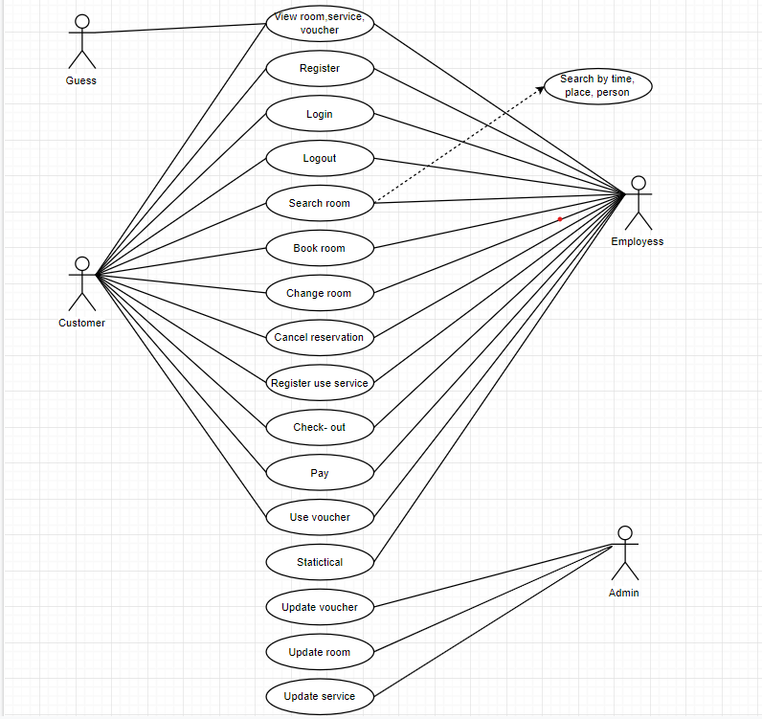

#### b. System Actors

|  |  |  |
| --- | --- | --- |
| **#** | **Actor** | **Description** |
| 1 | Customer | Visitors to the website will be able to see information such as Rooms, Services, and Special Offers. |
| 2 | Employee | _Perform activities such as looking, reserving accommodations, using services, making payments, etc.  _Revenue figures are broken out by the week, month, quarter, and year. |
| 3 | Admin | Admin will be in charge of updating the rooms and services as needed. |

#### c. Use Cases List

|  |  |  |  |
| --- | --- | --- | --- |
| **STT** | **UC name** | **Subject** | **Specific description** |
| UC1 | View room, service, voucher | Guest, Customer,  Employees | View information about rooms, services, and voucher displayed on the system |
| UC2 | Register | Customer, Employees | Create an account to login on the system |
| UC3 | Login | Customer, Employees | Login to use other functions on the system |
| UC4 | Logout | Customer, Employees | Log out of the system |
| UC5 | Search room | Customer, Employees | Search by filter day/month/year + number of people |
| UC6 | Book room | Customer, Employees | Confirm the registration to use the room |
| UC7 | Change room | Customer, Employees | Confirm room change and do the search again |
| UC8 | Cancel reservation | Customer, Employees | Cancellation Confirmation (Required 1 day before check-in) |
| UC9 | Register use service | Customer, Employees | Search and confirm the use of services at the hotel |
| UC10 | Check – out | Customer, Employees | Check-out confirmation |
| UC11 | Pay | Customer, Employees | Confirm payment via face-to-face or online |
| UC12 | Use voucher | Customer, Employees | Add voucher code to recalculate unit price |
| UC13 | Statistical | Customer, Employees | Calculate hotel revenue by day, week, month, year |
| UC14 | Update voucher | Admin | Update voucher information |
| UC15 | Update room | Admin | Update room information |
| UC16 | Update service | Admin | Update service information |

### 2.2 <<Booking Room >>

#### a. << View room, service, voucher >>

|  |  |  |  |
| --- | --- | --- | --- |
| Use Case ID | UC-01 | Use Case Name | View room, service, voucher |
| Create By | Group | Date Create |  |
| Primary Actor | Customer | Secondary Actor | Guest, Employees |
| Description | Actor can view information of hotel | | |
| Priority | Must have | | |
| Trigger | Users drag the screen up and down left and right to view information | | |
| Preconditions | The user clicks on the website's link | | |
| Post-Condition | N/A | | |
| Basic Flow | 1. Find the hotel links 2. Clicks links 3. See the information displayed on the screen | | |
| Alternative Flow | N/A | | |
| Exception Flow | N/A | | |

***c. << Register >>***

|  |  |  |  |
| --- | --- | --- | --- |
| Use Case ID | UC-02 | Use Case Name | Register |
| Create By | Group | Date Create |  |
| Primary Actor | Customer | Secondary Actor | Employees |
| Description | Users can create account and password | | |
| Priority | Must have | | |
| Trigger | Input information and click button register | | |
| Preconditions | The user clicks on the register | | |
| Post-Condition | User needs to enter the same password and re-enter the password | | |
| Basic Flow | 1. Click button register 2. Enter information 3. Registration confirmation | | |
| Alternative Flow | N/A | | |
| Exception Flow | **Same username**  The system displays a message with the same username asking to re-enter  **Password and re-enter password do not match**  The system displays an error message | | |

***d. << Login >>***

|  |  |  |  |
| --- | --- | --- | --- |
| Use Case ID | UC-03 | Use Case Name | Login |
| Create By | Group | Date Create |  |
| Primary Actor | Customer | Secondary Actor | Employees, Customer |
| Description | Users can login to the system | | |
| Priority | Must have | | |
| Trigger | Input information and click button login | | |
| Preconditions | The user clicks on the login | | |
| Post-Condition | User needs to enter the correct username and password respectively | | |
| Basic Flow | 1. Click button login 2. Enter information 3. Click button login | | |
| Alternative Flow | N/A | | |
| Exception Flow | **Username do not correct**  The system displays a message that needs to be re-entered  **Password do not correct**  The system displays a message that needs to be re-entered | | |

***e. << Logout >>***

|  |  |  |  |
| --- | --- | --- | --- |
| Use Case ID | UC-04 | Use Case Name | Logout |
| Create By | Group | Date Create |  |
| Primary Actor | Customer | Secondary Actor | Employees, Customer |
| Description | Users can logout to the system | | |
| Priority | Must have | | |
| Trigger | Input information and click button logout | | |
| Preconditions | The user clicks on the logout | | |
| Post-Condition | The user needs to confirm the logout operation | | |
| Basic Flow | 1. Click button logout 2. Click button “Are you sure logout” 3. System show success message | | |
| Alternative Flow | N/A | | |
| Exception Flow | N/A | | |

***f. << Search room >>***

|  |  |  |  |
| --- | --- | --- | --- |
| Use Case ID | UC-05 | Use Case Name | Search room |
| Create By | Group | Date Create |  |
| Primary Actor | Customer | Secondary Actor | Employees, Customer |
| Description | Users can find room to the system | | |
| Priority | Must have | | |
| Trigger | Click button find room | | |
| Preconditions | The user clicks on the find room | | |
| Post-Condition | Users need to select the location, date, number of guests staying | | |
| Basic Flow | 1. Choose location 2. Choose date 3. Choose number of guests staying 4. The system view page room from conditional (BF-05-04) 5. Click button find room | | |
| Alternative Flow | N/A | | |
| Exception Flow | **The user has not selected the location, date, number of guests staying**  The system displays a message that needs to be re-entered | | |

***g. << Book room >>***

|  |  |  |  |
| --- | --- | --- | --- |
| Use Case ID | UC-06 | Use Case Name | Book room |
| Create By | Group | Date Create |  |
| Primary Actor | Customer | Secondary Actor | Employees, Customer |
| Description | Users can book room to the system | | |
| Priority | Must have | | |
| Trigger | Click button book room | | |
| Preconditions | The user clicks on the book room | | |
| Post-Condition | Users need to select room from use case search room  System send an email room information after book room success | | |
| Basic Flow | 1. Click button book room 2. Enter information 3. Registration confirmation 4. System show success message | | |
| Alternative Flow | N/A | | |
| Exception Flow | **The user enters some missing information such as (Name, phone number, etc.**)  The system displays a message that needs to be re-entered | | |

***h. << Change room >>***

|  |  |  |  |
| --- | --- | --- | --- |
| Use Case ID | UC-07 | Use Case Name | Change room |
| Create By | Group | Date Create |  |
| Primary Actor | Customer | Secondary Actor | Employees, Customer |
| Description | Users can change room to the system | | |
| Priority | Must have | | |
| Trigger | Click button change room | | |
| Preconditions | The user clicks on the change room | | |
| Post-Condition | The customer had use-case book room | | |
| Basic Flow | 1. The user clicks on the button change room 2. The system view “Are you sure change room” 3. Users clicks on the button Yes 4. The system return BF-05-04 | | |
| Alternative Flow | N/A | | |
| Exception Flow | **The user clicks on the button No in form “Are you sure change room”**  The system return page | | |

***I. << Cancel reservation >>***

|  |  |  |  |
| --- | --- | --- | --- |
| Use Case ID | UC-08 | Use Case Name | Cancel reservation |
| Create By | Group | Date Create |  |
| Primary Actor | Customer | Secondary Actor | Employees, Customer |
| Description | Users can cancel room to the system | | |
| Priority | Must have | | |
| Trigger | Click button cancel room | | |
| Preconditions | The user clicks on the Cancel reservation | | |
| Post-Condition | The customer had use-case book room | | |
| Basic Flow | 1. The user clicks on the button Cancel reservation 2. The system view “Are you sure Cancel reservation” 3. Users clicks on the button Yes 4. The system returns use-case Search room 5. Users find and book room from UC-05 | | |
| Alternative Flow | N/A | | |
| Exception Flow | **The user clicks on the button No in form “Are you sure** Cancel reservation**”**  The system return page | | |

***j. << Register use service >>***

|  |  |  |  |
| --- | --- | --- | --- |
| Use Case ID | UC-09 | Use Case Name | Register use service |
| Create By | Group | Date Create |  |
| Primary Actor | Customer | Secondary Actor | Employees, Customer |
| Description | Users can use service to the system | | |
| Priority | Must have | | |
| Trigger | Click button Service | | |
| Preconditions | The user clicks on the Service | | |
| Post-Condition | The customer had use-case book room | | |
| Basic Flow | 1. The user clicks on the button Service 2. The system view Service page 3. Users find service want to use 4. User click in Add to cart for service 5. Get in Cart 6. Confirm use service | | |
| Alternative Flow | N/A | | |
| Exception Flow | **The user clicks on the button “+” in Cart**  Increase the number of services you want to use  **The user clicks on the button “-” Cart**  Reduce the number of services you want to use | | |

***k. << Change room >>***

|  |  |  |  |
| --- | --- | --- | --- |
| Use Case ID | UC-10 | Use Case Name | Check-out |
| Create By | Group | Date Create |  |
| Primary Actor | Customer | Secondary Actor | Employees, Customer |
| Description | Users can do check-out to the system | | |
| Priority | Must have | | |
| Trigger | Click button Check-out | | |
| Preconditions | The user clicks on the Check-out | | |
| Post-Condition | The customer had use-case book room | | |
| Basic Flow | 1. The system view Bill 2. User confirm Bill 3. Click button Confirm check-out | | |
| Alternative Flow | N/A | | |
| Exception Flow | N/A | | |

***l. << Use voucher >>***

|  |  |  |  |
| --- | --- | --- | --- |
| Use Case ID | UC-11 | Use Case Name | Use voucher |
| Create By | Group | Date Create |  |
| Primary Actor | Customer | Secondary Actor | Employees, Customer |
| Description | Users can use voucher to the system | | |
| Priority | Must have | | |
| Trigger | Click button Add voucher | | |
| Preconditions | The user clicks on the Add voucher | | |
| Post-Condition | The customer had use-case Check-out | | |
| Basic Flow | 1. The system view Bill page 2. User click button Add voucher 3. System have calculator and view total Bill again 4. User confirm Bill | | |
| Alternative Flow | N/A | | |
| Exception Flow | N/A | | |

***m. << Pay >>***

|  |  |  |  |
| --- | --- | --- | --- |
| Use Case ID | UC-12 | Use Case Name | Pay |
| Create By | Group | Date Create |  |
| Primary Actor | Customer | Secondary Actor | Employees, Customer |
| Description | Users can Pay to the system | | |
| Priority | Must have | | |
| Trigger | Click button Pay | | |
| Preconditions | The user clicks on the Pay | | |
| Post-Condition | The customer had use-case Check-out | | |
| Basic Flow | 1. The system view Pay page 2. User choose payment type 3. Confirm pay | | |
| Alternative Flow | N/A | | |
| Exception Flow | N/A | | |

***n. << Statistical >>***

|  |  |  |  |
| --- | --- | --- | --- |
| Use Case ID | UC-13 | Use Case Name | Statistical |
| Create By | Group | Date Create |  |
| Primary Actor | Employees | Secondary Actor | N/A |
| Description | Users can statistical to the system | | |
| Priority | Must have | | |
| Trigger | Click button statistical | | |
| Preconditions | The user clicks on the Statistical | | |
| Post-Condition | N/A | | |
| Basic Flow | 1. The system view Statistical page 2. Employees click button calculator 3. Employees choose calculator for week or month or year 4. The system view result | | |
| Alternative Flow | N/A | | |
| Exception Flow | N/A | | |

***o. << Update voucher >>***

|  |  |  |  |
| --- | --- | --- | --- |
| Use Case ID | UC-14 | Use Case Name | Update voucher |
| Create By | Group | Date Create |  |
| Primary Actor | Admin | Secondary Actor | N/A |
| Description | Admin can update voucher | | |
| Priority | Must have | | |
| Trigger | Click button update | | |
| Preconditions | Admin clicks on the update | | |
| Post-Condition | N/A | | |
| Basic Flow | 1. The system view Update voucher page 2. Admin click on the button “Add voucher” 3. The system view “Do you want at voucher” 4. Admin choose button “Yes” or “No” | | |
| Alternative Flow | N/A | | |
| Exception Flow | **Admin choose “Yes”**  The system view “Add success”  **Admin choose “No”**  The system view “ Add fault” | | |

***p. << Update room >>***

|  |  |  |  |
| --- | --- | --- | --- |
| Use Case ID | UC-15 | Use Case Name | Update room |
| Create By | Group | Date Create |  |
| Primary Actor | Admin | Secondary Actor | N/A |
| Description | Admin can update room | | |
| Priority | Must have | | |
| Trigger | Click button update | | |
| Preconditions | Admin clicks on the update | | |
| Post-Condition | N/A | | |
| Basic Flow | 1. The system view Update room page 2. Admin fix information room or add new room 3. Admin click on the button “Add room” 4. The system view “Do you want add room” 5. Admin choose button “Yes” or “No” | | |
| Alternative Flow | N/A | | |
| Exception Flow | **Admin choose “Yes”**  The system view “Add success”  **Admin choose “No”**  The system view “ Add fault” | | |

***q. << Update service >>***

|  |  |  |  |
| --- | --- | --- | --- |
| Use Case ID | UC-16 | Use Case Name | Update service |
| Create By | Group | Date Create |  |
| Primary Actor | Admin | Secondary Actor | N/A |
| Description | Admin can update service | | |
| Priority | Must have | | |
| Trigger | Click button update | | |
| Preconditions | Admin clicks on the update | | |
| Post-Condition | N/A | | |
| Basic Flow | 1. The system view Update service page 2. Admin fix information room or add new service 3. Admin click on the button “Add service” 4. The system view “Do you want add service” 5. Admin choose button “Yes” or “No” | | |
| Alternative Flow | N/A | | |
| Exception Flow | **Admin choose “Yes”**  The system view “Add success”  **Admin choose “No”**  The system view “ Add fault” | | |

## 3. Functional Requirements

### 3.1 System Functional Overview

#### a. Screen Flow

#### b. Screen Details

|  |  |  |  |
| --- | --- | --- | --- |
| **#** | **Feature** | **Screen** | **Description** |
| 1 | Authentication | Login | Allow guests to login into the system |
| 2 | Authentication | Register | Allow guests to create an account |
| 3 | Authentication | Reset password | Helps users to send request to reset their password |
| 4 | Profile | Change password | Change password helps users to create a new password |
| 5 | Profile | User Profile | View information of user |

#### c. Screen Authorization

|  |  |  |  |  |
| --- | --- | --- | --- | --- |
|  |  | User |  |  |
| Screen |  |  |  | Guest |
|  | Admin | Employees | Customer |  |
| Sign in | X | X | X |  |
| Sign up | X | X | X |  |
| Register |  |  |  | X |
| Home page |  | X | X | X |
| Search room |  | X | X | X |
| Book room |  |  | X | X |
| About hotel |  |  | X | X |
| List Service | X | X | X | X |
| Pay | X | X | X |  |
| Statistical | X | X |  |  |
| Gallery |  | X | X | X |
| Contact |  |  | X |  |
| View profile | X | X | X |  |
| Add, delete, update room | X |  |  |  |
| Add, delete, update service | X |  |  |  |
| Add, delete, update voucher | X |  |  |  |

## 4. Non-Functional Requirements

### 4.1 External Interfaces

#### a. User Interfaces

UI-1: Booking system in line with online user standards.

UI-2: The system shall provide a help link from each displayed web page to explain how to use that page.

UI-3: The web pages shall permit complete navigation and booking selection by using the keyboard alone, in addition to using mouse and keyboard combinations.

#### b. Software Interfaces

SI-1: Hotel Inventory System

SI-1.1: The system will transmit the number of rooms and services booked to the Hotel Inventory System through a programming interface.

SI-1.2: The system shall poll the Hotel Inventory System to determine whether a requested the number of rooms and services is available.

SI-1.3: When the Hotel Inventory System notifies the system that a specific the number of rooms and services is no longer available.

#### c. Hardware Interfaces

No hardware interfaces have been identified.

#### d. Communications Interfaces

CI-1: System will send email or text message (based on user account settings) to customer to confirm order acceptance, price and time.

CI-2: System will send an email or text message (based on user account settings) to the customer to report any issues with the booking and hotel services.

### 4.2 Quality Attributes

#### a. Usability

USAGE-1: The system will allow users to review bill history with just one interaction.

USAGE-2: 95% of new users can successfully book without error on first try.

#### b. Reliability

REL-1. No more than 5 experimental runs out of 1,000 can be lost because of software failures.

REL-2. The mean time between failures of the card reader component shall be at least 90 days.

#### c. Performance

PER-1: The system will contain a total of 400 users and a maximum of 100 concurrent users during the peak usage period which is the tourist season (Example: Tet, Holiday, Summer,...), with Estimated average session duration is 8 minutes.

PER-2: 95% of system-generated web pages will download completely within 4 seconds of the user requesting the page

PER-3: The system will display a confirmation message to the user within 3 seconds on average and up to 6 seconds after the user submits the information to the system.

*d. Dependability*

##### d1. Security

SEC-1: *The Customer will be able to see the reservation that they have made through the system.*

SEC-2: Personal data is involved in every network transaction.

##### d2. Safety

SAF-1: In any room, users will be able to see the information.

**Github code link of group 1**

https://github.com/quanghuytran2812/HotelHSM.git